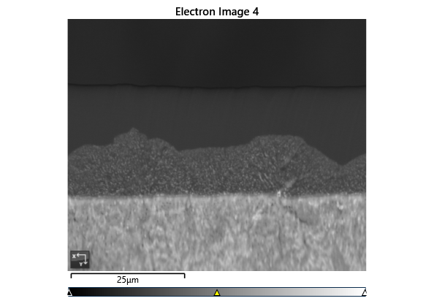

Settings

|  |  |
| --- | --- |
| Accelerating Voltage | 20.00 kV |
| Specimen Tilt (degrees) | 70.00 ° |
| Hit Rate | 85.22 % |
| Speed of Acquisition | 24.35 Hz |

Phases for Acquisition

|  |  |  |  |  |  |  |  |  |
| --- | --- | --- | --- | --- | --- | --- | --- | --- |
| Phase | a | b | c | Alpha | Beta | Gamma | Space Group | Database |
| Iron bcc (old) | 2.87 Å | 2.87 Å | 2.87 Å | 90.00 ° | 90.00 ° | 90.00 ° | 229 | HKL |
| Iron fcc | 3.66 Å | 3.66 Å | 3.66 Å | 90.00 ° | 90.00 ° | 90.00 ° | 225 | HKL |
| Nickel | 3.52 Å | 3.52 Å | 3.52 Å | 90.00 ° | 90.00 ° | 90.00 ° | 225 | OINA Phases |
| Pyrite | 5.42 Å | 5.42 Å | 5.42 Å | 90.00 ° | 90.00 ° | 90.00 ° | 205 | OINA Phases |

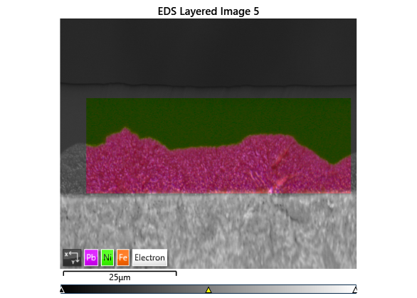

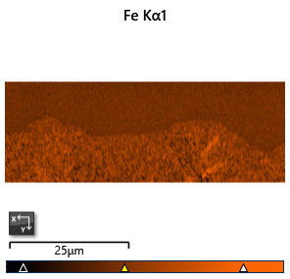

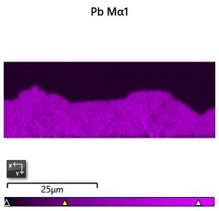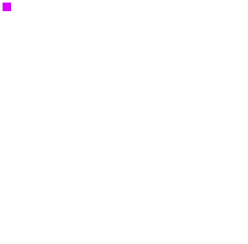

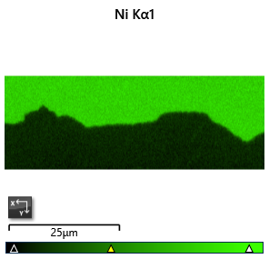

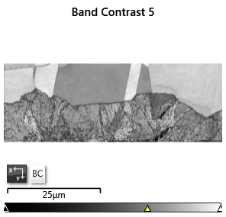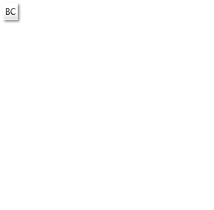

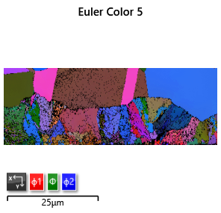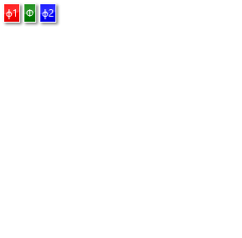

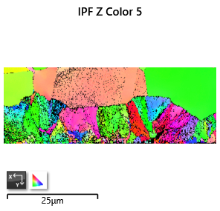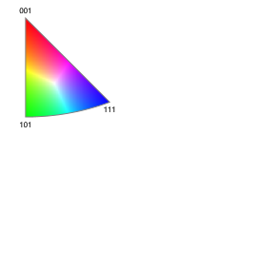

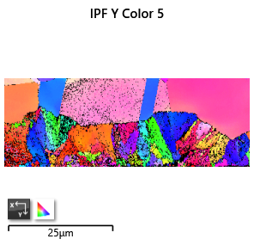

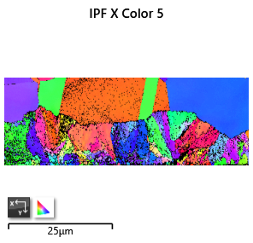

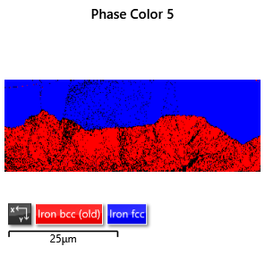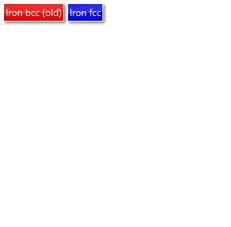

Phase Fraction

|  |  |  |  |  |  |  |  |  |  |  |
| --- | --- | --- | --- | --- | --- | --- | --- | --- | --- | --- |
| Phase Name | Phase Fraction (%) | Phase Count | Mean Band Contrast | Standard Deviation Band Contrast | Min Band Contrast | Max Band Contrast | Mean MAD | Standard Deviation MAD | Min MAD | Max MAD |
| Iron bcc (old) | 39.19 | 19181 | 94.28 | 12.84 | 23.00 | 132.00 | 0.83 | 0.29 | 0.22 | 2.00 |
| Iron fcc | 46.03 | 22530 | 111.10 | 11.08 | 33.00 | 134.00 | 0.68 | 0.33 | 0.12 | 2.00 |
| Nickel | 0.00 | 0 | 0.00 | 0.00 | 0.00 | 0.00 | 0.00 | 0.00 | 0.00 | 0.00 |
| Zero Solutions | 14.78 | 7233 | 79.97 | 19.24 | 0.00 | 130.00 |  |  |  |  |